**PIEP – CreationPS**

**User Guide**

## VERSIONING AND CONTROL VALIDATION

VERSIONING HISTORY

|  |  |  |  |
| --- | --- | --- | --- |
| Version | AUTHOR | REVISION | Date |
| 1.0 | RCAS (CGI) | Creation | 06/07/2020 |
| 1.1 | RCAS (CGI) | Review prerequisite | 17/08/2020 |
|  |  |  |  |
|  |  |  |  |
|  |  |  |  |
|  |  |  |  |
|  |  |  |  |

VALIDATION

|  |  |  |
| --- | --- | --- |
| Version | Name | Date |
| 1.0 |  |  |
|  |  |  |

## DOCUMENT CONTENT

1. VERSIONING AND CONTROL VALIDATION 2

2. DOCUMENT CONTENT 3

3. SCRIPT DESCRIPTION 4

3.1 Objective 4

3.2 Prerequisite 4

4. USER GUIDE 5

4.1 Prepare the input file 5

4.2 Configure 01-CreationPS.bat 5

4.3 Run CreationPS 6

4.4 Clean the application 6

## SCRIPT DESCRIPTION

### Objective

**The purpose of CreationPS is to create the tags PI in selected PI Server from csv files**.

The user provide the server name and the files extracted with CreationPS.

### Prerequisite

* Microsoft Powershell (1.0 or later).
* Package PI SMT 2018 or later.

## USER GUIDE

Copy the folder CreationPS in your local machine/server : **D:\PI\Applications**\.

### 4.1 Prepare the input file

Copy the files from the application ConfigurationPS to the Input folder.

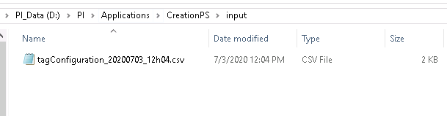

### 4.2 Configure 01-CreationPS.bat

Edit the file “.\script\01-CreationPS.bat”.

*cd ..*

*powershell.exe -file .\Creation.ps1 -PIServerHost "SERVER_NAME"*

Modify the following parameters :

* **PIServerHost** : Name of the PI Server to extract tags (exemple : PI-CENTER-HQ)

Then save the modifications and close the file.

### 4.3 Run CreationPS

**Run the script 01-CreationPS.bat**.

You should have the following window opened. Let the program create the tags.

The logs are stored in the “.\logs” directory.

When the line “Press Enter to quit CreationPS” appear, press Enter to quit.

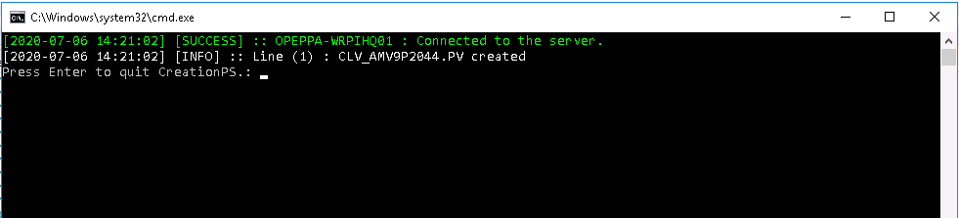

If some tags already exist on the server, or if the Creation in the input file is not good, you should have this message error. It does not stop the application process, but the current tag won’t be created in the server.

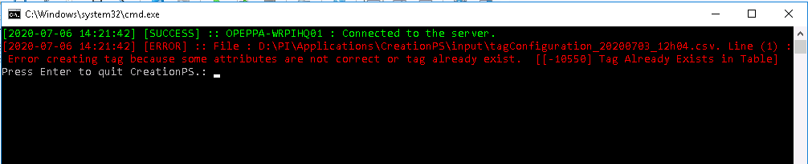

### 4.4 Clean the application

When the Creation is finished, do not forget to clean the input directory for the next use.